510 22nd Avenue East, Suite 701 • Alexandria, MN 56308
Ph: 320-763-9711 • Fax: 320-762-1278

Name: _______________________________________________________ Birthdate: ______/______/________ Gender: F / M
Address: _________________________________________ City: _________________________ State: ______ Zip: ______________
Home Phone: ________________Cell Phone: __________________ Work Phone: __________________ SSN: __________________
Preferred method of communication: Email / Phone / Mail / Text Medical Doctor: _____________________ May we contact: Y/N
Email: ________________________________ Occupation: ______________________ Employer: __________________________
Marital Status: M/S/W/D Spouse: __________________ Spouse’s Employer: _________________ Number of Children: ____

Medication Name (provide list if available) Dosage and Frequency (i.e. 5mg once a day, etc.)

Nutritional Supplement Name (provide list if available) Dosage and Frequency (i.e. 5mg once a day, etc.)

Medication Allergy Reaction Onset Date Additional Comments

How did you hear about us? □ Yellow Pages □ Internet □ TV □ Doctor □ Print Ad □ Event □ Friend/Family/Other
Whom may we thank for referring you? _______________________________________________________________________
Assignment and Release:
I hereby consent to treatment by the doctor(s) at Central Lakes Chiropractic Clinic. If applicable, I hereby consent
treatment for my minor child(ren).
I understand, certify that I (or my dependent) have personal health insurance coverage with __________________ and
assign directly to this office all insurance benefits, if any, otherwise payable to me for services rendered. I understand
that I am personally responsible for all charges accrued whether or not paid, or covered, by my insurance. I hereby
authorize the doctor to release all information necessary to secure the payment of benefits. I authorize the use of this
signature on all insurance submissions.

We accept Health Savings Account (HSA) as a form of payment. Please let us know if you have a HSA account.

Patient Signature: ______________________________________________ Date: _______________________
Patient Current Health Condition:

What is your major complaint: _________________________________________________________________________
How long have you had this condition: ________ Is this condition: □Getting better □Getting worse □Staying the same
What do you think caused this condition: ________________________________________________________________
Is your condition the result of: □Car Accident □Work Injury Date of Injury:________ Injury Report Filed: □Yes □No
What makes this condition worse: ______________________________________________________________________
What makes this condition better: ______________________________________________________________________
Is this condition interfering with: □Work □Sleep □Daily routine □Other: ____________
Other doctors/therapists that have treated this condition: __________________________________________________
Other healing methods you used for this condition: □Massage □Acupuncture □Physical Therapy □Nutritional Therapy

Mark the area of your symptoms on the figure below:

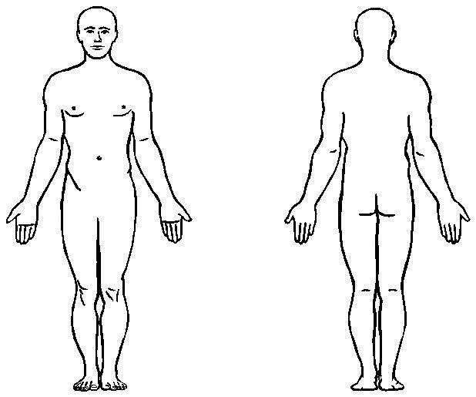
How bad are your symptoms now:
______________________________________________
No Pain 0 1 2 3 4 5 6 7 8 9 10 Severe

How bad have your symptoms been in the past:
______________________________________________
No Pain 0 1 2 3 4 5 6 7 8 9 10 Severe

Social History:
Mental Work: □Heavy □Moderate □Light □Hours per day: ____________
Physical Work: □Heavy □Moderate □Light □Hours per day: ____________
Exercise: □Heavy □Moderate □Light □Hours per day: ____________
□Yoga □Pilates □Weights □Cardio □Other: _______
Smoking Status: □Current □Previous Packs per day ______No. of years: _______
Alcohol: Beer/Wine ___________ Liquor per week ____No. of years: _______
Caffeine: Coffee/Tea ___________ Soda _________ Servings per day: _______
Aspirin/Tylenol/Ibuprofen: Amount per day ____________ How long ___________

Review of Systems and Symptoms: Check only the ones you have had in the past or are currently having.
Include all issues even if you don’t think chiropractic can help.

Musculo-Skeletal System Genito-Urinary System Gastro-Intestinal System
□Arm/Hand problems □Bladder trouble □Abdominal pain
□Arthritis □Difficult urination □Acid reflux
□Difficulty walking □Discolored urine □Bloody stool
□Fracture □Excessive urination □Constipation
□Leg/Hip problems □Incontinence □Diabetes
□Low back pain □Painful urination □Diarrhea
□Neck pain □Difficulty swallowing
□Pain between shoulders Female Only □Excessive hunger
□Pain in TMJ/jaw □Breast Pain □Excessive thirst
□Painful joints □Excessive bleeding □Gall bladder trouble
□Shoulder problems □Lump on breast □Hemorrhoids
□Sore muscles □Vaginal discharge □Indigestion
□Stiff joints □Vaginal pain □Liver trouble
□Swollen joints Are you pregnant? □Nausea
□Weak Muscles □Yes □No □Poor appetite
Date of last cycle: __________ □Vomiting

Nervous System Cardio-Vascular/Respiratory System EENT System
□Anxiety □Asthma □Ear discharge
□Confusion □Chest pain □Ear pain
□Convulsion □Difficulty breathing □Eye strain
□Depression □Excessive phlegm □Hearing loss
□Dizziness □Heart condition □Hoarseness
□Fatigue □High blood pressure □Nasal discharge
□Headaches □Low blood pressure □Nose bleeds
□Insomnia □Lung condition □Ringing in the ear
□Light headedness □Persistent cough □Sore gums
□Loss of feeling □Rapid heartbeat □Sore throat
□Memory problems □Varicose veins □Vision problems
□Migraines
□Numbness Endocrine System
□Paralysis □ Thyroid
□ Other ___________

Past Medical History: Check only the conditions you have had in the past.
□Alcoholism □Allergies □Angina
□Cancer □Colon problems □Disc herniation
□Epilepsy □Gall stones □Hay fever
□Heart attack □Heart trouble □Hepatitis
□Kidney stones □Mumps □Phlebitis
□Polio □Prostate Problems □Shingles
□STD □Stroke □Tumor
□Ulcers Date of last physical: ____________

Surgeries: Please include implants/cosmetic surgery. ____________________________________________________
__________________________________________________________________________________________________
510 22nd Avenue East, Suite 701 • Alexandria, MN 56308
Ph: 320-763-9711 • Fax: 320-762-1278

Informed Consent Document
The nature of the chiropractic adjustment.
The primary treatment used by doctors of chiropractic is the spinal adjustment, using hands or a mechanical instrument upon your body in such a way as to move your joints. That may cause an audible “pop” or “click”, much as you have experienced when you “crack” your knuckles. You may feel a sense of better movement, may have temporary stiffness and/or soreness during the first few days of treatment, and/or the pain that you presented with may move to a new area.
The probability of risks occurring in the chiropractic adjustment.
As with any healthcare procedure, there are certain complications which may arise during chiropractic care.
The doctor will make every reasonable effort during the examination to screen for contraindications to care; however, if you have a condition that would otherwise not come to the doctor’s attention it is your responsibility to inform the doctor.
Fractures are rare occurrences and generally result from some underlying weakness of the bone which the doctor checks for during the taking of your history and during examination and x-ray. Stroke and/or vertebral artery dissection caused by chiropractic adjustment of the neck has been the subject of ongoing research.
The most current research on the topic is inconclusive as to the specific incidence of this complication occurring. If there is a causal relationship, it is extremely rare.
The availability and nature of other treatment options.
Other treatment options for your condition may include:
•Self-administered, over-the-counter analgesics and rest
•Medical care and prescription drugs, such as anti-inflammatory, muscle relaxants, pain-killers
•Hospitalization, Surgery
If you chose to use one of the above noted other treatment options, you may wish to discuss risks of those options with your medical doctor.
The risks and dangers attendant to remaining untreated.
Remaining untreated may allow the formation of adhesions and reduce mobility which may set up a chronic pain reaction. Over time this process may complicate treatment, making it more difficult and less effective the longer it is postponed.

Please check the appropriate box and sign below.
□ I have read or □ I have had read to me the above explanation of the chiropractic adjustment.

I have had my questions answered to my satisfaction. By signing below, I state that I understand the possible risks involved in undergoing chiropractic treatment and have decided that it is in my best interest to undergo the treatment recommended. Having read this document, I hereby give my consent to treatment.

_______________ ___________________________________ ___________________________________
Date Patient Name Signature of Patient or Guardian (if minor)

510 22nd Avenue East, Suite 701 • Alexandria, MN 56308
Ph: 320-763-9711 • Fax: 320-762-1278

Acknowledgment of Receipt of HIPAA Privacy Notice

I, ____________________________________, have been notified of this office Notice of Privacy Practices that have been clearly posted in the front reception area. I understand that I have certain rights to privacy regarding my protected health information.
I understand that this information can and will be used to:
•Conduct, plan and direct my treatment and follow up among the health care providers who may be directly and indirectly involved in providing my treatment.
•Obtain payment from third party payers.
•Conduct normal health care operations, such as quality assessments and accreditation.

_____________________________________________________________ ________________________
Patient Name Chart Number

______________________________________________________________ ________________________
Patient Signature Date

For office use only:
We attempted to obtain written Acknowledgment of Receipt of our Notice of Privacy Practices, but Acknowledgment could not be obtained because:
□ Individual refused to sign
□ Communication barriers prohibited obtaining the Acknowledgement
□ An emergency situation prevented us from obtaining Acknowledgement
□ Other (specify) ____________________________________________________________________________

______________________________________________________________ ________________________
Staff Signature Date

